Oussama ACCOUCH
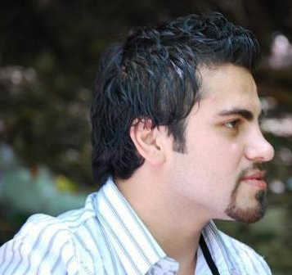
Curriculum Vitae
E-mail: oussama.accouch@gmail.com
Address: Lebanon, Saida, Kharayeb
Mobile: +961 3 847 901
Citizenship: Lebanese
Gender: Male
Objective
Highly motivated electrical engineer looking to obtain a position in your esteemed organization, where i will have the opportunity of using my engineering education to analyze complex engineering problems, evaluate and recommend alternatives.
Education
Lebanese University – Faculty of Engineering III
- 2006-2011: Electrical -Electronics Engineering “Industrial Digital Control”.
Lebanese Bac
- 2005-2006: General Sciences.
Final Year Projects (2010/2011) “Grade: Excellent”
Computerized Control of “Asphalt Plant” with AKHDAR INTERNATIONAL TRADING COMPANY
- PLC programming for the full automation “Beckhoff plc CX9010”
- Measuring control algorithm using “Matlab fuzzy logic toolbox”
- SCADA using Csharp.net throw Ethernet ADS protocol
- Sensors studying, testing and installing
University Projects “most important”
Fourth year 2009-2010:
- Power meter with lcd display using Pic micro-controller “PIC CCS”, “Proteus” simulation
Fifth year 2010-2011:
- DC to DC converter hardware in:80~120v dc out:48v dc “PWM”
- Dimensioning of high and medium voltage electrical network
- Electrical installation using “Ecodial”
Computer skills

Programming languages:
- C / C++ / C#4.0
- Java / Java mobile
- MATLAB
- Labview
- HTML / ASP.net/Silverlight
Control and automation:
- Ladder / SFC / ST / IL / FBD
Design:
- AutoCAD
Microsoft Office:
- Word / Excel / PowerPoint / Visio

Languages details
- Arabic : Native language
- English: read/write/listen/Speak: Fluent
- French: read/write/listen: very good Speak: good
Soft skills
- Ability to work in a group or individually according to the job requirements.
- Interactive and fast enough to learn new technologies.
- Advanced Research Abilities.
- High Communications Skills.
- Self-Motivated.
Community Experience & Awards
- Member of the team who took the 4th place in java mobile competition “NNA-NOKIA” 2010.
- Writer in the scientific magazine “EUREKA”.
- Member of Students council.
Experience & Projects

- Spring 2010: NOKIA “NNA-Mobile Application” competition participation
Java mobile application using”NetBeans”.

- July - August 2010: Training at Beirut-Rafic Hariri International Airport “MEAS”
MV- LV Power Distribution Systems, Power Management System.
- August 2010: Training at “ITEC”
Twincat System Manager, Twincat PLC Control, Twincat target visualization.
- September – October 2010: Work “independent”
Electrical installation of RAPANELLI Oil-press machine including: electrical maps, cables dimensions, control panel design, installation and operation.
- July – August 211: Work with “AKHDAR INTERNATIONAL TRADING COMPANY”
Electrical installation of CIFA 160t/h Beton mixing plant including: electrical maps, cables dimensions, control panel design, installation and operation.
- August – September – October 2011: Work with “AKHDAR INTERNATIONAL TRADING”
Automation and installation of CIFA 200t/h Beton mixing plant including: electrical maps, cables dimensions, control panel design, PLC automation software, C# windows based software as SCADA, installation and operation.
- January 2012: Work with “AKHDAR MACHINERY TRADING”
Control panel for Crushing plant 600KVA, electrical maps, cables dimensions, control panel design.
Hobbies
- Basketball, Tennis, Reading physics and new technologies.
References are available upon request

