Serdar Kahveci
Mechanical Engineer
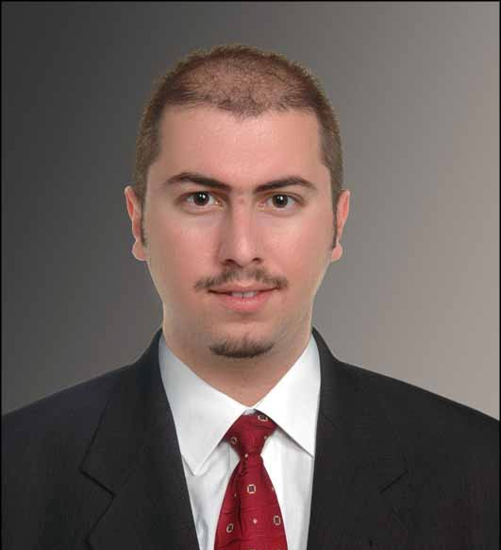
Int. Welding Engineer (IIW&EWF)

Contact

Adress : Alemadi Suits B block 305 Sana RA Doha Qatar
Adress 2 : 1586 Ada Ayçiçek Vadisi Evleri D8 Blok D2
Camili 1 Adapazarı Sakarya Turkiye
Cell Turkey : +90 535 980 77 31
Cell Qatar : +974 663 207 63
e-mail : serdar.kahveci@gmail.com

General

Graduate : University Date of Birth : 1/20/1983
Marital Status : Married Place of Birth : Kocaeli / Turkey
Experience : 8 Years Driving Licence : Qatari and Turkish
Military Service : Done (01.06.2008) Nationality : Turkey

Education

07.2009 - 11.2009 : International Institute of Welding İstanbul / Turkey
International Welding Engineer
European Welding Engineer

09.2003 - 08.2007 : Sakarya University Sakarya / Turkey
Engineering Faculty - Mechanical Engineer
Graduation Thesis : Sheet Metal Mold Design

09.2000 - 08.2002 : Sakarya University Sakarya / Turkey
Vocational High School
Mechanical Technician
Graduation Thesis : Building Mechanical Systems

09.1996 - 06.1999 : Derince High School Kocaeli / Turkey
Science

Experience

06.2010 - 09.2011 : Ekin Proje

Project : New Doha İnternational Airport Project Doha / Qatar
Department : Quality Assurance - Sn. Engineer
Material Receiving Inspections
Method of Staintments Preperation

Department : Quality Control - Sn. Engineer
Quality Action Notice Coordination
Welding Inspections
Chilled Water Inspections
HVAC Inspections

01.2010 - 06.2010 : Germanischer Lloyd – Inspecco

Project : AREVA Transformer - New Plant Building Kocaeli / Turkey
Department : Quality Control - Sn. Engineer
All Mechanical Diciplines Controller

Project : Various Company And Projects Turkey
Department : Quality Assurance - Sn. Engineer
WPS Preperation
WPQR Preperation
Welder Certification Preperation

07.2008 - 07.2009 : ODES Fire Protection Systems

Project : Turquaz Petrol – Plant Kocaeli / Turkey
Pozition : Construction Chief
Fire Fighting Systems Management

Project : Sun Chemical – Plant Kocaeli / Turkey
Pozition : Construction Chief
Fire Fighting Systems Management

Project : Hayat Chemical – Plant Kocaeli / Turkey
Pozition : Construction Chief
: Fire Fighting Systems Management

10.2003 - 06.2006 : Arkadya Engineering Ltd Co

Project : More than hundred house, plant; natural gas and Sakarya / Turkey
mechanical systems design and construction.

Pozition : Design And Constuction Engineer Management

Language

: English Good
: Turkish Native
Qualifications

: Computer Skills
Windows Excellent
MS Office Excellent
Auto Cad Good
Pro Engineer / Wild Fire Excellent

: Engineering Skills
Mechanical Systems Excellent
Natural Gas Systems Excellent
CAD Excellent
Welding & Welding Methods Excellent

Hobbies

: Riding Motorcycle
: Playing Guitar
: Sailing
: Snowboard

Reference

: Coşkun Yeni
Sn Construction Manager
VOLTAS LTD Sidra Hospital Qatar
yenicoskun@hotmail.com

: Aycan Kayrakcı
Project Manager
Ekin Project NDIA Project Qatar
akayrakci@ekinproje.com

